**PROJECT REPORT TEMPLATE**

**1. INTRODUCTION**

**1.1 Overview**

The hotel industry is a broad category of businesses that provide lodging services for travelers and tourists. This can include a wide range of establishments, from luxury resorts to budget-friendly motels, as well as extended stay hotels, boutique hotels, and more. Hotels can be found in nearly every corner of the world, and are often a major component of the tourism and travel industry in a given area.

Radisson owns multiple five-star hotels across India. They have been in the hospitality industry for the past 100 years. Due to strategic moves from other competitors and ineffective decision-making in management, Radisson is losing its market share and revenue in the luxury/business hotels category.

**1.2 Purpose**

Radisson is losing its market share and revenue in the luxury/business hotels category. As a strategic move, the managing director of Radisson wanted to incorporate Business and Data Intelligence in order to regain their market share and revenue. Our task is to create an analytics dashboard & story to provide them insights to make better business decisions.

**2. PROBLEM DEFINITION & DESIGN THINKING**

**2.1 Empathy Map**

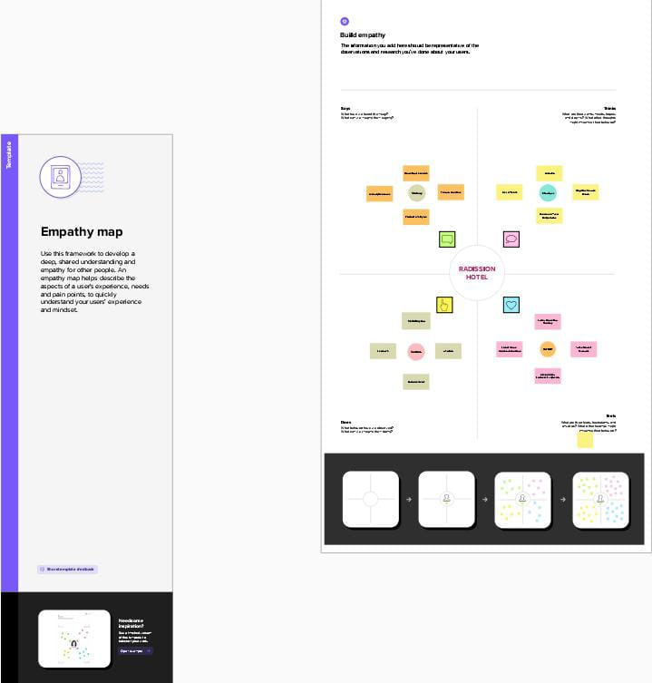

**2.2 Ideation & Brainstorming Map**

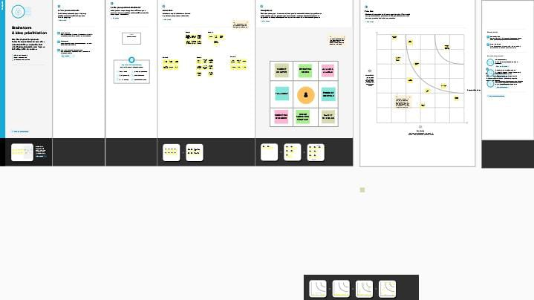

**DASHBOARD**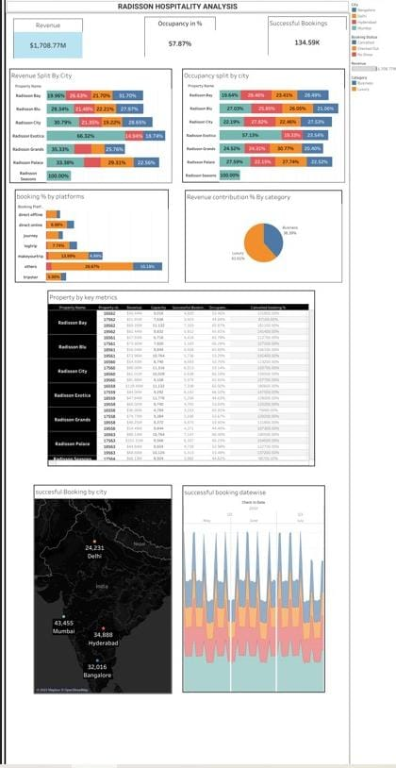

**STORY**

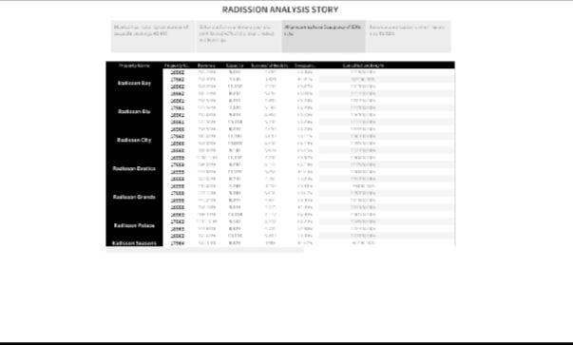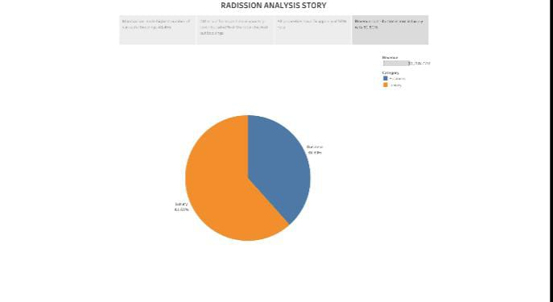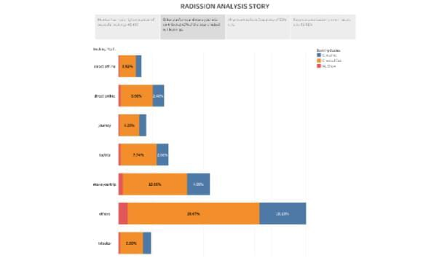

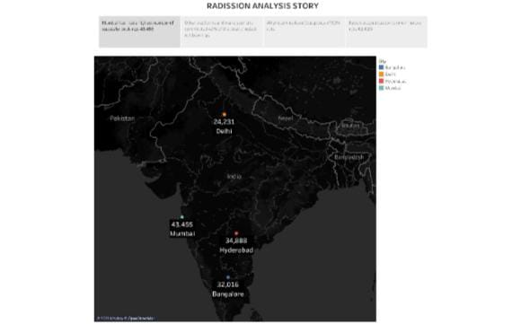

**ADVANTAGES & DISADVANTAGES**

**Advantages:**

* one of the leading international hotel groups in the country with seven distinct brands
* Creative hospitality and innovative spirit.
* Members save up to 10% more when booking directly on the website or mobile app.

**Disadvantages:**

* The brand name comes with a perception of being expensive.
* economic status is bound to take a toll on spending power.
* Still trying to establish itself in the emerging economies.

**APPLICATION:**

* Radisson Hotels is an international hotel chain headquartered in the United States.
* A division of the Radisson Hotel Group it operates the brand Radisson Blue, Radisson, Radisson RED, Radisson Individuals, Park Plaza, Park Inn by Radisson, Country Inn & Suites by Radisson hotels
* Radisson hotel to provide travellers with shelter, food, refreshment, and similar services and goods

**CONCLUSION**

The conclusion of this project is the Radisson hotel focused on the needs of today’s travellers, the Group has evolved its portfolio by introducing hotels and resorts that offer contemporary indulgences, elevated guest experiences and superior design quality.

**FUTURE SCOPE**

* Hoping and aiming for full recovery in terms of travel demand on the development side .
* The increase inflation and cost debt will cost are challenge but also bring an opportunity and will most likely drive to innovate exiting upcoming next.